
E-Commerce Customer Churn Analysis
Business Data Analytics
BHATASANA, Jainilkumar Hiteshbhai
2026

DECLARATION:
I hereby affirm that this dissertation is the result of my own work and was not submitted in collaboration with any other person or organization. Every source used has been properly referenced and credited.

I offer permission to the International Business School to freely utilize any portion or all of the dissertation, including replication online or electronically, and adaption for educational and instructional purposes.
Janil Bhatasana

ACKNOWLEDGEMENT
I would like to express my sincere gratitude to everyone who supported and guided me throughout the completion of this dissertation. This project has been an important learning experience that allowed me to develop both technical and analytical skills in the field of business data analytics and machine learning.
First and foremost, I would like to thank my project supervisor for providing valuable guidance, constructive feedback, and continuous support during every stage of this research. Their suggestions and academic direction helped me improve the quality of this project and better understand the practical applications of machine learning and business analytics in real-world scenarios.
I would also like to thank the faculty members of the International Business School for providing the academic knowledge, resources, and learning environment necessary for completing this dissertation successfully. The knowledge gained throughout the MSc IT for Business Data Analytics programme played a major role in shaping the technical and analytical foundation required for this research.
Special thanks to the online developer and research communities whose educational resources, tutorials, and documentation helped me overcome technical challenges during the implementation phase of the project. Access to open-source tools, machine learning libraries, and publicly available datasets greatly supported the successful development of this system.
I am also grateful to the creators and contributors of the Kaggle platform for making the e-commerce customer churn dataset publicly available for research and academic purposes. The availability of high-quality datasets is extremely valuable for students and researchers working in the field of data analytics.
Finally, I would like to express my heartfelt appreciation to my family and friends for their constant encouragement, patience, and emotional support throughout this academic journey. Their motivation helped me stay focused and complete this dissertation with confidence and determination.
Completing this project has been a valuable experience that strengthened my understanding of machine learning, customer analytics, and business intelligence, and it has motivated me to continue exploring advanced applications of data analytics in the future.

EXECUTIVE SUMMARY
Customer retention has become one of the most critical challenges in the modern e-commerce industry. As customer acquisition costs continue to increase, organizations are increasingly focusing on predictive analytics and intelligent customer segmentation techniques to improve customer retention and profitability. This project presents a machine learning-based framework for customer churn prediction and customer segmentation using RFM (Recency, Frequency, Monetary) analytics within the e-commerce domain.
The primary objective of this project is to develop an intelligent analytics system that identifies customers likely to discontinue using e-commerce services and categorizes them into meaningful behavioral segments. The study uses an e-commerce customer churn dataset from Kaggle that includes demographic, transactional, and behavioral information on customer purchasing patterns.
The methodology adopted in this project includes several stages such as data collection, preprocessing, handling missing values, feature engineering, scaling, exploratory data analysis, clustering, predictive modeling, and performance evaluation. Missing values were handled using median imputation techniques to ensure data consistency and reliability. Label encoding was applied to categorical variables to prepare the dataset for machine learning algorithms.
To perform customer segmentation, the RFM framework was implemented using recency, frequency, and monetary indicators derived from the dataset. K-Means clustering was applied to categorize customers into four distinct groups based on purchasing behavior. The Elbow Method was utilized to determine the optimal number of clusters.
For churn prediction, a Random Forest classifier was implemented due to its robustness, high predictive capability, and ability to handle complex datasets. The developed model achieved an accuracy of 94%, demonstrating strong predictive performance. Model evaluation was conducted using classification metrics, ROC-AUC analysis, feature importance analysis, and correlation heatmaps.
The findings indicate that machine learning and customer segmentation techniques can significantly improve customer retention strategies by identifying high-risk customers and enabling personalized business interventions. The project also demonstrates how RFM analytics can provide actionable business intelligence for marketing optimization and customer relationship management.
The project contributes to the growing field of business data analytics by integrating predictive modeling with customer behavior analysis in a practical e-commerce environment. Future enhancements may include deep learning models, real-time analytics systems, and deployment through cloud-based business intelligence platforms.

TABLE OF CONTENTS

DECLARATION: 2
Chapter 1. INTRODUCTION 9
1.1 Background of the Study 9
1.2 Problem Statement 9
1.3 Aim of the Project 10
1.4 Objectives of the Study 10
1.5 Scope of the Study 10
1.6 Significance of the Study 10
1.7 Structure of the Dissertation 11
Chapter 2. LITERATURE REVIEW 12
2.1 Introduction 12
2.2 Customer Churn in E-Commerce 12
2.3 Machine Learning in Customer Analytics 13
2.4 Customer Segmentation Techniques 14
2.5 RFM Analytics Framework 15
2.6 Research Gap 16
Chapter 3. METHODOLOGY 18
3.1 Introduction 18
3.2 Research Design 18
3.3 Dataset Collection 19
3.4 Data Understanding and Initial Exploration 20
3.5 Data Preprocessing 20
3.5.1 Handling Missing Values 21
3.5.2 Encoding Categorical Variables 21
3.5.3 Feature Selection 22
3.6 Feature Engineering Using RFM Analytics 22
3.6.1 Recency 22
3.6.2 Frequency 23
3.6.3 Monetary Value 23
3.6.4 Importance of RFM Analytics 23
3.7 Data Scaling and Normalization 23
3.8 Customer Segmentation Using K-Means Clustering 24
3.8.1 Elbow Method 24
3.8.2 Cluster Generation 24
3.9 Customer Churn Prediction Using Random Forest 25
3.9.1 Train-Test Split 25
3.9.2 Model Training 26
3.10 Model Evaluation 26
3.10.1 Accuracy 26
3.10.2 Precision 26
3.10.3 Recall 26
3.10.4 F1-Score 26
3.10.5 ROC-AUC Analysis 26
3.10.6 Feature Importance Analysis 26
3.11 Visualization Techniques 27
3.12 Model Saving and Deployment Readiness 27
Chapter 4. EXPLORATORY DATA ANALYSIS 28
4.1 Introduction 28
4.2 Dataset Overview 28
4.3 Statistical Summary of the Dataset 29
4.4 Missing Value Analysis 29
4.5 Customer Churn Distribution Analysis 30
4.6 Analysis of Customer Tenure 30
4.7 Cashback and Monetary Behavior Analysis 31
4.8 Customer Engagement Analysis 31
4.9 Correlation Heatmap Analysis 32
4.10 RFM Analysis and Customer Behavior Patterns 33
4.11 Importance of EDA in Machine Learning Implementation 34
Chapter 5. IMPLEMENTATION OF ALGORITHMS AND MODELS 35
5.1 Introduction 35
5.2 System Architecture Overview 35
5.3 Development Environment and Tools 37
5.3.1 Pandas 37
5.3.2 Scikit-learn 37
5.3.3 Matplotlib and Seaborn 38
5.3.4 Joblib 38
5.4 Data Loading and Initial Implementation 38
5.5 Data Cleaning and Preprocessing Implementation 39
5.5.1 Missing Value Handling 39
5.5.2 Encoding Categorical Variables 39
5.6 Feature Engineering Using RFM Analytics 39
5.6.1 Recency Implementation 39
5.6.2 Frequency Implementation 40
5.6.3 Monetary Implementation 40
5.6.4 Importance of RFM Feature Engineering 40
5.7 Data Scaling Implementation 40
5.8 K-Means Clustering Implementation 41
5.8.1 Elbow Method Implementation 41
5.8.2 Cluster Generation 41
5.9 Random Forest Implementation for Churn Prediction 41
5.9.1 Train-Test Split 42
5.9.2 Model Training 42
5.9.3 Prediction Generation 42
5.10 Model Evaluation Implementation 43
5.10.1 Accuracy Evaluation 43
5.10.2 Classification Report 43
5.10.3 ROC-AUC Evaluation 43
5.11 Feature Importance Implementation 43
5.12 Correlation Heatmap Implementation 44
5.13 Model Storage and Deployment Readiness 44
5.14 Business Significance of the Implemented Models 45
Chapter 6. RESULTS AND ANALYSIS 46
6.1 Introduction 46
6.2 Customer Segmentation Results Using the Elbow Method 46
6.3 Churn Prediction Performance 47
6.4 Feature Importance Analysis 48
6.5 ROC Curve and AUC Analysis 50
6.6 Correlation Heatmap Analysis 51
6.7 Overall Analytical Findings 52
7.1 Introduction 54
7.2 Business Insights from Customer Segmentation 54
7.2.1 High-Value Loyal Customers 54
7.2.2 Regular Active Customers 55
7.2.3 Low-Engagement Customers 55
7.2.4 At-Risk Customers 55
7.3 Business Insights from Churn Prediction 56
7.4 Importance of Customer Retention in E-Commerce 57
7.5 Recommendations for E-Commerce Businesses 58
7.5.1 Implement Personalized Marketing 58
7.5.2 Strengthen Loyalty Programs 58
7.5.3 Improve Customer Complaint Resolution 58
7.5.4 Optimize Delivery and Logistics 59
7.5.5 Use Predictive Analytics for Decision-Making 59
7.6 Strategic Importance of Business Analytics 59
7.7 Summary 60
CONCLUSION 61
REFERENCES 63
APPENDIX 65
APPENDIX A: DATASET INFORMATION 65
APPENDIX B: SAMPLE DATA RECORDS 65
APPENDIX C: SOURCE CODE IMPLEMENTATION 66
APPENDIX D: MACHINE LEARNING MODEL OUTPUTS 67
APPENDIX E: VISUALIZATION OUTPUTS 67
APPENDIX F: GITHUB REPOSITORY LINK 69

Chapter 1. INTRODUCTION

1.1 Background of the Study
The rapid growth of digital commerce has transformed customer purchasing behavior and business operations across industries. E-commerce organizations generate vast amounts of customer-related data through online transactions, browsing activities, purchase histories, and customer interactions. As competition within the digital marketplace continues to intensify, customer retention has become one of the most important strategic priorities for e-commerce businesses.
Customer churn refers to the phenomenon where customers stop engaging with a company’s products or services over time. High churn rates can significantly affect organizational profitability because acquiring new customers is substantially more expensive than retaining existing customers. Consequently, organizations are increasingly adopting business analytics and machine learning techniques to predict customer churn and improve customer retention strategies.
Machine learning techniques provide organizations with the ability to analyze historical customer behavior, identify hidden patterns, and generate predictive insights regarding future customer actions. Simultaneously, customer segmentation enables businesses to group customers based on purchasing patterns and behavioral similarities, allowing organizations to create personalized marketing strategies.
This project focuses on integrating customer churn prediction with customer segmentation using RFM analytics in an e-commerce environment. The proposed framework combines unsupervised learning techniques for customer segmentation with supervised learning methods for churn prediction to provide comprehensive business intelligence.

1.2 Problem Statement
Customer attrition represents a major challenge in the e-commerce industry. Businesses often struggle to identify customers who are likely to leave the platform before churn occurs. Traditional marketing approaches frequently fail to provide personalized retention strategies due to the inability to analyze customer behavior effectively.
Additionally, many organizations lack intelligent systems capable of simultaneously predicting customer churn and segmenting customers according to purchasing behavior. This limitation reduces the effectiveness of customer retention campaigns and impacts long-term business growth.
Therefore, there is a need for an intelligent business analytics framework that can accurately predict customer churn while identifying meaningful customer segments using machine learning and RFM analytics.

1.3 Aim of the Project
This project aims to develop a machine learning-based framework for customer churn prediction and customer segmentation using RFM analytics within the e-commerce domain.

1.4 Objectives of the Study
The primary objectives of this project are:
- To analyze customer behavior using e-commerce transactional data.
- To preprocess and prepare the dataset for machine learning implementation.
- To implement RFM analytics for customer segmentation.
- To apply K-Means clustering for identifying customer groups.
- To develop a Random Forest-based churn prediction model.
- To evaluate model performance using machine learning metrics.
- To derive actionable business insights for customer retention.

1.5 Scope of the Study
This study focuses on the application of machine learning and business analytics techniques within the e-commerce domain. The project utilizes a publicly available e-commerce customer churn dataset and applies customer segmentation and churn prediction techniques.
The scope includes:
- Data preprocessing and cleaning
- Exploratory data analysis
- Feature engineering using RFM analytics
- Customer segmentation using K-Means clustering
- Customer churn prediction using Random Forest
- Visualization and business interpretation of findings
The study does not include real-time deployment, cloud infrastructure implementation, or deep learning architectures.

1.6 Significance of the Study
The significance of this project lies in its ability to support business decision-making through predictive analytics and customer intelligence. The developed system can assist organizations in:
- Identifying customers likely to churn
- Improving customer retention strategies
- Enhancing personalized marketing campaigns
- Optimizing customer relationship management
- Increasing customer lifetime value
- Reducing customer acquisition costs
The integration of machine learning with RFM analytics also contributes academically to the field of business data analytics by demonstrating practical applications of predictive modeling in e-commerce environments.

1.7 Structure of the Dissertation
This dissertation is organized into multiple chapters.
Chapter 1 introduces the research background, objectives, significance, and scope of the study.
Chapter 2 presents the literature review related to customer churn prediction, customer segmentation, machine learning algorithms, and RFM analytics.
Chapter 3 discusses the research methodology, including data preprocessing, feature engineering, and model development.
Chapter 4 presents the exploratory data analysis and visualization of customer behavior patterns.
Chapter 5 explains the implementation of machine learning algorithms and clustering models.
Chapter 6 presents the experimental results and analytical interpretations.
Chapter 7 discusses business insights and strategic recommendations derived from the findings.
Chapter 8 concludes the dissertation, outlines limitations, and provides suggestions for future work.

Chapter 2. LITERATURE REVIEW

2.1 Introduction
Customer churn prediction and customer segmentation have become important research areas in business analytics, customer relationship management, and machine learning. The rapid growth of e-commerce platforms has generated large amounts of customer transaction data, allowing businesses to apply predictive analytics techniques for improving customer retention and business performance.
Machine learning algorithms are increasingly used to identify customer behavior patterns, predict churn risks, and support personalized marketing strategies. This chapter reviews existing studies related to customer churn prediction, customer segmentation, machine learning applications, and RFM analytics within the e-commerce industry.
The chapter also identifies limitations in previous studies and highlights the research gap addressed by this project.

2.2 Customer Churn in E-Commerce
Customer churn refers to the situation where customers stop using a company’s services or discontinue purchasing products from a business. In e-commerce industries, customer churn is considered a major challenge because losing customers directly affects organizational profitability and market competitiveness.
According to Kotler and Keller [9], retaining existing customers is more cost-effective than acquiring new customers. Businesses therefore focus heavily on customer retention strategies to maintain long-term profitability.
Lemmens and Gupta [11] explained that effective churn management can significantly improve customer lifetime value and business revenue. Their research highlighted the importance of identifying churn risks early to support proactive retention strategies.
Ahmed, Mahmud and Islam [1] stated that customer churn prediction has become one of the most important applications of machine learning in e-commerce environments because customer transaction data contains meaningful behavioral patterns that can support predictive analytics.
Similarly, Xu, Walton and Wang [20] discussed how e-commerce businesses increasingly rely on predictive analytics systems to identify customers likely to leave online platforms.
Traditional churn analysis methods relied mainly on statistical analysis and manual customer monitoring. However, modern machine learning techniques provide more scalable and accurate approaches for analyzing large customer datasets [15].
The increasing competition among e-commerce companies has made customer retention a strategic business priority. Factors such as pricing, customer satisfaction, delivery performance, and promotional offers strongly influence customer loyalty and churn behavior.
Machine learning therefore plays an important role in helping businesses improve customer engagement and reduce customer attrition.

2.3 Machine Learning in Customer Analytics
Machine learning has transformed customer analytics by enabling organizations to automatically identify hidden patterns and relationships within customer data.
According to Hastie, Tibshirani and Friedman [6], machine learning algorithms are capable of learning complex data relationships and generating predictive models with strong analytical performance.
Machine learning techniques are widely applied in business analytics for:
- customer churn prediction,
- fraud detection,
- recommendation systems,
- customer lifetime value analysis,
- and personalized marketing.
Provost and Fawcett [15] emphasized that predictive analytics allows businesses to move from reactive decision-making to proactive business strategies.
Several machine learning algorithms have been used for churn prediction, including:
- Logistic Regression,
- Decision Trees,
- Support Vector Machines,
- Gradient Boosting,
- Artificial Neural Networks,
- and Random Forest.
Among these algorithms, Random Forest has become highly popular because of its strong predictive capability and robustness.
Breiman [3], who introduced the Random Forest algorithm, explained that ensemble learning improves classification accuracy by combining multiple decision trees and reducing overfitting problems.
Random Forest is especially suitable for customer churn prediction because it can:
- handle large datasets,
- process mixed feature types,
- identify feature importance,
- and generate stable predictions.
Rahman, Islam and Hasan [16] found that Random Forest achieved high performance in online retail churn prediction due to its ability to analyze complex customer behavior relationships.
Pedregosa et al. [14] also highlighted the importance of Scikit-learn as a powerful machine learning library that simplifies the implementation of predictive analytics models within Python environments.
Machine learning therefore provides organizations with efficient analytical tools for understanding customer behavior and improving customer retention strategies.

2.4 Customer Segmentation Techniques
Customer segmentation refers to the process of dividing customers into groups based on shared characteristics or behavioral similarities.
Segmentation allows businesses to better understand customer diversity and design targeted marketing strategies for different customer groups.
According to Tsiptsis and Chorianopoulos [18], customer segmentation is one of the most important techniques in customer relationship management because customers have different purchasing behaviors and engagement patterns.
Customer segmentation may be based on:
- demographic characteristics,
- geographic factors,
- psychographic information,
- or behavioral patterns.
Behavioral segmentation is especially important within e-commerce environments because customer purchasing activities provide meaningful business insights.
Machine learning techniques have significantly improved customer segmentation by enabling automated discovery of hidden customer behavior patterns.
K-Means clustering is one of the most widely used unsupervised learning algorithms for customer segmentation.
Jain [7] described K-Means clustering as an effective algorithm for partitioning data into clusters based on similarity.
The algorithm works by minimizing the distance between data points and cluster centroids.
K-Means clustering operates through iterative processes involving:
- centroid initialization,
- customer assignment,
- centroid recalculation,
- and convergence optimization.
Ngai, Xiu and Chau [13] explained that clustering techniques improve customer relationship management by supporting targeted marketing and personalized customer engagement strategies.
Customer segmentation provides several business advantages, including:
- improved customer understanding,
- optimized marketing expenditure,
- targeted promotions,
- and personalized recommendations.
Despite its advantages, K-Means clustering also has limitations.
According to Jain [7], K-Means requires predefined cluster counts and may be sensitive to initial centroid selection.
However, due to its simplicity and scalability, K-Means remains highly suitable for customer analytics applications.

2.5 RFM Analytics Framework
RFM analytics is one of the most widely used customer analysis frameworks in customer relationship management and marketing analytics.
RFM stands for:
- Recency,
- Frequency,
- and Monetary value.
The framework evaluates customer behavior based on purchasing recency, purchasing frequency, and spending behavior.
The basic principle behind RFM analytics is that customers who purchased recently, purchase frequently, and spend more money are generally more valuable to businesses.
Recency measures how recently customers interacted with the business or made purchases.
Customers with lower recency values are usually more engaged and less likely to churn.
Frequency measures how often customers interact with the platform.
High-frequency customers are generally more loyal and contribute more revenue to businesses.
Monetary value measures how much customers spend on products or services.
Customers with high monetary values are often considered premium customers.
Tsiptsis and Chorianopoulos [18] explained that RFM analytics is highly effective for customer segmentation because it focuses directly on customer purchasing behavior.
Similarly, Ngai, Xiu and Chau [13] highlighted that RFM analysis supports customer retention management and personalized marketing strategies.
Businesses use RFM analytics to:
- identify loyal customers,
- detect inactive customers,
- optimize promotional campaigns,
- and improve customer relationship management.
The integration of RFM analytics with machine learning techniques further improves customer segmentation quality and predictive performance.
RFM analytics is especially suitable for e-commerce systems because online transaction platforms generate large amounts of customer purchasing data.

2.6 Research Gap
Although customer churn prediction and customer segmentation have been widely researched, several important limitations remain within existing studies.
One major limitation is that many studies focus only on customer churn prediction without integrating customer segmentation techniques.
While churn prediction identifies customers likely to leave, it does not always provide detailed understanding of customer behavior groups.
Similarly, some studies focus only on customer segmentation without implementing predictive analytics.
This separation limits the ability of businesses to combine behavioral analysis with churn prediction for personalized retention strategies.
Another limitation is that several studies rely heavily on demographic variables while giving less importance to behavioral and transactional indicators.
Ahmed, Mahmud and Islam [1] highlighted that customer transaction behavior often provides stronger predictive insights compared to demographic data.
Many previous studies also provide limited business interpretation. Technical machine learning outputs are frequently discussed without explaining practical business applications.
Additionally, some studies do not include feature importance analysis, ROC-AUC evaluation, or visualization techniques that improve interpretability and business understanding.
Another limitation is that many research studies rely on single analytical approaches rather than integrating multiple business analytics techniques within one framework.
This project addresses these limitations by integrating:
- RFM analytics,
- customer segmentation,
- churn prediction,
- feature importance analysis,
- and business interpretation
within a single machine learning framework.
The project combines K-Means clustering and Random Forest classification to generate both predictive intelligence and customer behavior insights.
The study also emphasizes practical business recommendations alongside technical analysis, improving the real-world applicability of the framework.

Chapter 3. METHODOLOGY

3.1 Introduction
This chapter explains the methodology used to develop the machine learning-based customer churn prediction and customer segmentation system for the e-commerce industry. The methodology includes all stages of the project, starting from data collection and preprocessing to machine learning implementation and model evaluation.
The purpose of the methodology is to transform raw customer transaction data into meaningful business intelligence capable of supporting customer retention and customer relationship management strategies.
The project combines both supervised and unsupervised machine learning approaches. Supervised learning was implemented for customer churn prediction, while unsupervised learning was applied for customer segmentation.
The methodology adopted in this study follows a structured business analytics workflow consisting of:
- Data collection and understanding
- Data preprocessing and cleaning
- Feature engineering using RFM analytics
- Data scaling and normalization
- Customer segmentation using K-Means clustering
- Churn prediction using Random Forest
- Model evaluation and visualization
- Business interpretation of results
The combination of predictive analytics and customer segmentation helps generate both technical insights and practical business recommendations.

3.2 Research Design
This study follows a quantitative and experimental research design.
Quantitative research methods are appropriate because the project involves numerical customer data, statistical analysis, predictive modeling, and machine learning implementation.
The experimental approach was adopted because different machine learning techniques were implemented and evaluated using customer transaction data.
The research process involved:
- data preprocessing,
- feature engineering,
- clustering,
- classification,
- and model performance evaluation.
The methodology also follows a data-driven analytical framework where business decisions are derived from customer behavioral patterns and predictive insights.
The use of machine learning techniques allows the project to analyze large customer datasets efficiently and identify hidden relationships within customer transaction behavior.

3.3 Dataset Collection
The dataset used in this project was obtained from the Kaggle platform.
Dataset Source: https://www.kaggle.com/datasets/samuelsemaya/e-commerce-customer-churn
The dataset contains customer-related information collected from an e-commerce environment.
The primary purpose of the dataset is to support customer churn prediction and customer behavior analysis using machine learning techniques.
The dataset includes multiple customer attributes related to:
- customer demographics,
- transaction behavior,
- customer engagement,
- purchasing activities,
- and churn status.
The target variable in the dataset is the churn indicator, which identifies whether customers have churned or remained active.
The dataset contains both numerical and categorical variables, making preprocessing necessary before machine learning implementation.
Some important variables included in the dataset are:
- Tenure
- CashbackAmount
- WarehouseToHome
- DaySinceLastOrder
- NumberOfAddress
- SatisfactionScore
- PreferedOrderCat
- MaritalStatus
- Complain
- Churn
These variables provide meaningful insights into customer behavior and purchasing patterns.
The dataset was selected because it contains realistic customer transaction information suitable for predictive analytics and customer segmentation tasks within the e-commerce industry.

3.4 Data Understanding and Initial Exploration
Before implementing machine learning algorithms, the dataset was explored to understand its structure, data types, and statistical properties.
The dataset was loaded into the Python environment using the Pandas library.
Initial exploration was conducted using functions such as:
- Head ()
- info ()
- describe ()
- isnull()
The head () function was used to display the first few rows of the dataset and understand the structure of customer records.
The info () function provided information about:
- data types,
- total records,
- and missing values.
The describe () function generated statistical summaries including:
- mean,
- standard deviation,
- minimum values,
- maximum values,
- and quartile distributions.

This statistical analysis helped identify patterns and potential anomalies within the dataset.
The isnull() function was used to identify missing values present in customer attributes.
Understanding the dataset before preprocessing is important because machine learning algorithms perform better when the data is clean, consistent, and properly formatted.
The initial exploration stage also helped identify categorical variables that required encoding before model implementation.

3.5 Data Preprocessing
Data preprocessing is one of the most important stages in machine learning projects.
Raw datasets often contain:
- missing values,
- inconsistent formatting,
- noisy data,
- and irrelevant information.

These issues can negatively affect machine learning performance if not handled properly.
In this project, preprocessing was carefully performed to improve data quality and model reliability.

3.5.1 Handling Missing Values
The dataset contained missing values in several columns, including:
- DaySinceLastOrder
- WarehouseToHome

Missing values can reduce predictive accuracy and introduce bias into machine learning models.
To address this issue, median imputation was applied.
Median imputation replaces missing values with the median value of the corresponding feature.
The median was selected instead of the mean because customer transaction data may contain outliers. Median values are less sensitive to extreme observations and therefore provide more robust preprocessing.
The following preprocessing operations were performed:
- Missing values in DaySinceLastOrder were replaced with the median value.
- Missing values in WarehouseToHome were replaced with the median value.
- Remaining numerical missing values were also filled using median imputation.

After preprocessing, the dataset was checked again to ensure that all missing values had been successfully removed.
Handling missing values improved dataset consistency and ensured that the machine learning models could process the data effectively.

3.5.2 Encoding Categorical Variables
Machine learning algorithms generally require numerical input data.
However, the dataset contained categorical variables such as:
- PreferredOrderCat
- MaritalStatus
These variables could not be processed directly by machine learning algorithms.
To solve this issue, Label Encoding was implemented using Scikit-learn’s LabelEncoder.
Label Encoding converts text-based categorical values into numerical representations.
For example:
- Electronics → 0
- Grocery → 1
- Fashion → 2

Encoding categorical variables allowed the machine learning algorithms to identify relationships between customer categories and churn behavior.
The encoding process also improved computational efficiency and simplified model training.

3.5.3 Feature Selection
Feature selection is important because irrelevant variables may reduce model performance and increase computational complexity.
In this project, features directly related to customer engagement and transaction behavior were retained for analysis.
The selected features included:
- purchasing behavior,
- engagement indicators,
- customer satisfaction variables,
- and transaction-related attributes.

The target variable, Churn, was separated from the independent variables before model training.
Feature selection improved model efficiency and helped focus the analysis on variables most relevant to customer retention behavior.

3.6 Feature Engineering Using RFM Analytics
Feature engineering refers to the process of creating meaningful variables that improve machine learning performance.
This project implemented RFM analytics, which is one of the most widely used customer segmentation frameworks in marketing and customer relationship management.
RFM stands for:
- Recency
- Frequency
- Monetary Value

These three variables help businesses understand customer purchasing behavior and customer value.

3.6.1 Recency
Recency measures how recently customers interacted with the platform.
In this project:
Recency = DaySinceLastOrder
Customers with lower recency values are generally more active and engaged.
Recent customer interaction often indicates stronger customer loyalty and lower churn probability.

3.6.2 Frequency
Frequency measures how often customers interact with the platform.
In this project:
Frequency = Tenure
Customers with higher frequency values usually demonstrate stronger engagement and long-term loyalty.
Frequency analysis helps businesses identify active customers and evaluate customer engagement levels.

3.6.3 Monetary Value
Monetary value measures how much customers spend on the platform.
In this project:
Monetary = CashbackAmount
High monetary values often indicate valuable customers who contribute significantly to business revenue.
Monetary analysis helps businesses identify premium customer groups and optimize loyalty programs.

3.6.4 Importance of RFM Analytics
RFM analytics provides several business advantages.
First, it supports customer segmentation based on actual purchasing behavior rather than only demographic information.
Second, it improves personalized marketing by identifying different customer engagement patterns.
Third, it helps businesses identify customers at risk of churn before disengagement occurs.
Finally, RFM analytics improves customer relationship management by helping organizations focus resources on high-value customers.
The implementation of RFM analytics strengthened both the clustering process and churn prediction performance.

3.7 Data Scaling and Normalization
Machine learning algorithms such as K-Means clustering are sensitive to differences in feature magnitudes.
For example:
- CashbackAmount may contain larger numerical values,
- while Recency values may contain smaller values.

Without normalization, variables with larger magnitudes may dominate the clustering process.
To solve this issue, StandardScaler was applied.
StandardScaler normalizes features using mean normalization and standard deviation scaling.
The scaling formula is:
z = (x − μ) / σ
where:
- x represents the original value,
- μ represents the mean,
- σ represents the standard deviation.

Normalization ensured that all RFM variables contributed equally during clustering implementation.
Data scaling improved clustering quality and reduced bias caused by feature magnitude differences.

3.8 Customer Segmentation Using K-Means Clustering
Customer segmentation was implemented using the K-Means clustering algorithm.
K-Means is an unsupervised machine learning algorithm used to group similar data points into clusters.
The purpose of clustering in this project was to identify customer groups with similar purchasing behavior patterns.

3.8.1 Elbow Method
Selecting the optimal number of clusters is an important step in clustering analysis.
The Elbow Method was used to determine the appropriate cluster count.
The method calculates inertia values for different cluster numbers and plots them on a graph.
Inertia measures the total within-cluster variation.
A sharp reduction in inertia followed by a gradual decline indicates the optimal cluster count.
The Elbow Method graph showed that four clusters represented the optimal customer segmentation structure.

3.8.2 Cluster Generation
After determining the optimal cluster count, K-Means clustering was implemented with four clusters.
The algorithm grouped customers according to similarities in:
- recency,
- frequency,
- and monetary behavior.

Each cluster represented a different customer behavior category.
These customer groups can support businesses in designing targeted marketing and customer retention strategies.
Examples include:
- loyal customers,
- active customers,
- inactive customers,
- and at-risk customers.

Customer segmentation improves personalization and customer relationship management.

3.9 Customer Churn Prediction Using Random Forest
After customer segmentation, customer churn prediction was implemented using the Random Forest classifier.
Random Forest is an ensemble learning algorithm that combines multiple decision trees to improve predictive accuracy.
The algorithm was selected because of its:
- strong classification performance,
- robustness,
- low overfitting risk,
- and the ability to handle mixed datasets.

Random Forest is highly suitable for customer churn prediction because customer transaction behavior often contains complex relationships.
The algorithm learns patterns from historical customer data and predicts whether customers are likely to churn.

3.9.1 Train-Test Split
The dataset was divided into:
- training data,
- and testing data.

An 80:20 ratio was used.
Training data was used to train the model, while testing data was used to evaluate predictive performance.
This approach ensured unbiased model evaluation.

3.9.2 Model Training
The Random Forest model was trained using customer behavioral features.
The algorithm analyzed relationships between customer activities and churn outcomes.
After training, the model generated churn predictions for unseen testing data.
The predictive system achieved strong performance because the selected features captured meaningful customer behavior patterns.

3.10 Model Evaluation
Model evaluation is essential for measuring predictive effectiveness and reliability.
Several evaluation metrics were implemented in this project.

3.10.1 Accuracy
Accuracy measures the proportion of correctly predicted customer records.
The Random Forest classifier achieved an accuracy of 94%.
This result indicates strong predictive capability.

3.10.2 Precision
Precision measures how many predicted churn customers actually churned.
High precision reduces false positive predictions.

3.10.3 Recall
Recall measures the ability of the model to correctly identify actual churn customers.
High recall is important because undetected churn customers may result in customer loss.

3.10.4 F1-Score
The F1-score combines precision and recall into a single evaluation metric.
It is especially useful for classification problems involving class imbalance.

3.10.5 ROC-AUC Analysis
The ROC curve evaluates classification performance across different threshold values.
The AUC score measures the model’s ability to distinguish between churn and non-churn customers.
The generated AUC score was approximately 0.98, indicating excellent classification performance.

3.10.6 Feature Importance Analysis
Feature importance analysis was conducted to identify variables contributing most significantly to churn prediction.
This analysis helped identify important customer behavior indicators influencing customer retention.

3.11 Visualization Techniques
Visualization techniques were used to improve the interpretation and communication of analytical findings.
The following visualizations were generated:
- Elbow Method graph,
- ROC curve,
- correlation heatmap,
- and a feature importance graph.
Visual representations improved the understanding of customer behavior patterns and machine learning performance.
Visualization also supported business interpretation of analytical results.

3.12 Model Saving and Deployment Readiness
After successful training and evaluation, the developed models were saved using the Joblib library.
The following files were generated:
- churn_model.pkl
- scaler.pkl
- kmeans_model.pkl
Saving trained models improves deployment readiness and allows future integration into real-world business systems.
The saved models can later be integrated into web applications, business intelligence systems, or cloud-based analytics platforms.

Chapter 4. EXPLORATORY DATA ANALYSIS

4.1 Introduction
Exploratory Data Analysis (EDA) is one of the most important stages in data analytics and machine learning projects. EDA helps researchers understand the structure of the dataset, identify hidden patterns, analyze relationships among variables, and detect anomalies that may affect model performance.
In this project, exploratory data analysis was conducted to examine customer behavior within the e-commerce dataset and identify important trends related to customer churn and purchasing activities.
The analysis focused on:
- statistical summaries,
- customer behavior patterns,
- feature relationships,
- correlation analysis,
- customer engagement trends,
- and clustering insights.
The findings generated during EDA played an important role in selecting relevant features, designing the machine learning models, and interpreting customer behavior from a business perspective.
EDA also improved understanding of the dataset before implementing machine learning algorithms such as K-Means clustering and Random Forest classification.

4.2 Dataset Overview
The dataset used in this project contains customer-related information collected from an e-commerce platform. The dataset includes both numerical and categorical variables associated with customer demographics, purchasing behavior, customer engagement, and churn status.
Important variables included in the dataset are:
- Tenure
- CashbackAmount
- WarehouseToHome
- DaySinceLastOrder
- NumberOfAddress
- SatisfactionScore
- PreferredOrderCat
- MaritalStatus
- Complain
- Churn

The dataset contains customer records that help analyze how customer activities influence retention and churn behavior.
The dataset includes both continuous and categorical variables, making preprocessing and statistical analysis important before implementing predictive analytics models.
The target variable in the project is the Churn column, which identifies whether customers remained active or discontinued using the platform.

4.3 Statistical Summary of the Dataset
Statistical analysis was performed using the describe() function in Python to understand the distribution of numerical variables.
The statistical summary generated important information such as:
- mean,
- median,
- standard deviation,
- minimum values,
- maximum values,
- and quartile distributions.

The statistical analysis showed that several customer-related variables had varying distributions across the dataset.
For example, variables such as CashbackAmount and Tenure showed noticeable variation among customers, indicating differences in customer engagement and spending behavior.
The analysis also revealed that some variables contained wider ranges of values, suggesting the presence of both low-value and high-value customers within the dataset.
Understanding statistical distributions was important because it helped identify:
- customer purchasing trends,
- engagement variations,
- and potential outliers.

The statistical summary also supported feature engineering decisions during the implementation of RFM analytics.

4.4 Missing Value Analysis
The dataset initially contained missing values in several important columns, including:
- Day Since Last Order
- Warehouse To Home

Missing values are common in real-world datasets and can negatively affect machine learning performance if not handled properly.
A missing value analysis was conducted using the isnull() function to identify incomplete records.
The analysis showed that only a limited number of missing values were present in the dataset.
To maintain data consistency, median imputation was applied during preprocessing.
Median values were selected because they are less sensitive to extreme observations compared to mean values.
Handling missing values improved dataset quality and ensured that the machine learning models could process customer records effectively.
The missing value analysis also highlighted the importance of data preprocessing in business analytics projects.

4.5 Customer Churn Distribution Analysis
One of the most important analyses performed during EDA involved examining the distribution of churn customers and non-churn customers.
Understanding churn distribution is important because class imbalance can affect machine learning performance.
The analysis showed that the majority of customers remained active, while a smaller percentage of customers churned.
This imbalance is common in customer churn datasets because most businesses typically retain a larger proportion of customers compared to those who leave.
The churn distribution analysis provided several important business insights.
First, it confirmed that customer churn is a significant issue within e-commerce environments because even a relatively small percentage of churn customers can result in substantial revenue loss.
Second, the imbalance highlighted the importance of selecting evaluation metrics beyond simple accuracy during model assessment.
Metrics such as:
- precision,
- recall,
- F1-score,
- and ROC-AUC
became important because they provide better understanding of predictive performance for churn cases.
From a business perspective, the churn distribution analysis demonstrates why predictive analytics systems are necessary for customer retention management.

4.6 Analysis of Customer Tenure
Customer tenure represents the duration of customer engagement with the platform.
The analysis of tenure revealed significant differences between customers with long-term engagement and customers with shorter engagement periods.
Customers with higher tenure values generally demonstrated:
- stronger engagement,
- more frequent transactions,
- and lower churn probability.
On the other hand, customers with lower tenure values appeared more likely to churn.
This finding indicates that long-term customer relationships contribute significantly to customer retention.
The tenure analysis also supports the feature importance results generated later during churn prediction.
From a business perspective, this analysis suggests that organizations should prioritize customer onboarding and long-term relationship management strategies.
Improving customer experience during the early stages of engagement may increase customer loyalty and reduce churn probability.

4.7 Cashback and Monetary Behavior Analysis
CashbackAmount was one of the important variables analyzed during EDA because it reflects customer spending behavior and promotional engagement.
The analysis revealed noticeable variation in cashback values among customers.
Some customers received significantly higher cashback amounts, indicating higher spending behavior and stronger platform engagement.
The analysis suggests that cashback programs may positively influence customer retention and purchasing frequency.
Customers receiving attractive cashback incentives are more likely to continue using the platform and engage in repeated purchases.
However, the analysis also showed that excessive dependence on promotional offers may increase marketing costs if not managed effectively.
From a business analytics perspective, cashback analysis helps organizations optimize reward programs and design effective customer loyalty strategies.
The monetary analysis also contributed to the RFM framework used later during customer segmentation.

4.8 Customer Engagement Analysis
Customer engagement patterns were analyzed using variables such as:
- Frequency,
- Recency,
- Tenure,
- and SatisfactionScore.
The analysis showed that highly engaged customers generally demonstrated:
- frequent interactions,
- recent purchasing activity,
- and higher satisfaction levels.
Customers with low engagement levels often showed higher churn probability.
This finding confirms the importance of customer activity and interaction patterns in predicting customer retention behavior.
The engagement analysis also demonstrated that customer satisfaction and platform interaction strongly influence loyalty.
From a business perspective, improving customer engagement may help reduce churn and increase customer lifetime value.
Businesses can improve engagement through:
- personalized recommendations,
- reward systems,
- targeted marketing,
- and improved customer support.

4.9 Correlation Heatmap Analysis
A correlation heatmap was generated to examine relationships among customer variables.
Correlation analysis helps identify:
- positive relationships,
- negative relationships,
- and dependencies between variables.
The heatmap revealed several important relationships within the dataset.
One of the strongest positive correlations was observed between:
- Frequency and Tenure,
- Monetary and CashbackAmount.
The positive relationship between frequency and tenure indicates that long-term customers tend to interact more frequently with the platform.
Similarly, the strong relationship between monetary value and cashback amount suggests that customers who spend more money generally receive larger promotional rewards.
The heatmap also revealed a negative relationship between churn and tenure.
This indicates that customers with longer engagement duration are less likely to churn.
The correlation analysis further showed that behavioral variables contributed more significantly to customer retention than demographic variables.
This finding supports the importance of behavioral analytics in customer churn prediction systems.
The heatmap also validated the effectiveness of the RFM framework because meaningful relationships existed among recency, frequency, and monetary variables.
From a business perspective, correlation analysis provides valuable insights into customer purchasing behavior and engagement patterns.

4.10 RFM Analysis and Customer Behavior Patterns
RFM analytics was implemented to better understand customer purchasing behavior.
The analysis focused on:
- Recency,
- Frequency,
- and Monetary value.
Customers with:
- low recency,
- high frequency,
- and high monetary value
were generally identified as highly valuable customers.
These customers are important because they contribute significantly to business revenue and platform stability.
On the other hand, customers with:
- high recency,
- low frequency,
- and low monetary value
appeared more likely to churn.
The RFM analysis helped identify behavioral differences among customer groups before implementing clustering algorithms.
From a business perspective, RFM analysis provides practical support for:
- customer segmentation,
- loyalty programs,
- retention strategies,
- and personalized marketing campaigns.
The findings confirmed that RFM analytics effectively captures customer engagement characteristics within e-commerce platforms.

4.11 Importance of EDA in Machine Learning Implementation
The exploratory data analysis stage played an important role in improving the overall quality of the machine learning framework.
EDA helped:
- identify missing values,
- understand feature distributions,
- detect important relationships,
- select relevant variables,
- and support feature engineering decisions.
Without EDA, machine learning models may be trained using poor-quality or irrelevant data, reducing predictive performance.
The analysis also improved interpretability because understanding customer behavior patterns allowed the machine learning outputs to be connected with practical business insights.
EDA, therefore, acted as a bridge between raw customer data and business intelligence generation.

Chapter 5. IMPLEMENTATION OF ALGORITHMS AND MODELS

5.1 Introduction
This chapter explains the implementation of the machine learning algorithms and analytical models used in this project for customer segmentation and customer churn prediction within the e-commerce industry.
The implementation phase focused on transforming the prepared dataset into a predictive analytics framework capable of generating customer behavior insights and churn predictions.
The project implemented both unsupervised and supervised machine learning techniques.
The unsupervised learning component involved customer segmentation using the K-Means clustering algorithm, while the supervised learning component focused on churn prediction using the Random Forest classifier.
In addition to model implementation, this chapter also discusses:
- feature engineering,
- model training,
- model evaluation,
- optimization techniques,
- and visualization methods.
The algorithms were implemented using Python and several machine learning libraries including:
- Pandas,
- Scikit-learn,
- Matplotlib,
- Seaborn,
- and Joblib.
The implementation process followed a structured machine learning workflow designed to improve predictive accuracy and analytical reliability.

5.2 System Architecture Overview
The developed system follows a structured architecture beginning from data collection and ending with predictive outputs and business insights.
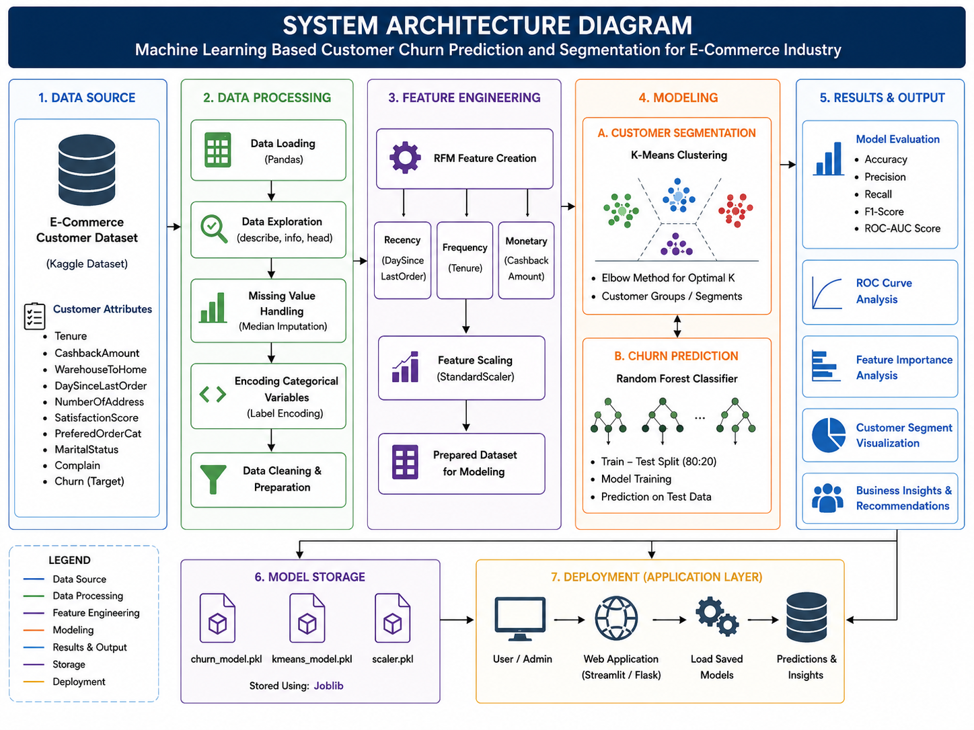
Fig. 1. System Architecture

The system architecture consists of the following major components:
- Data Source Layer
- Data Processing Layer
- Feature Engineering Layer
- Modeling Layer
- Results and Visualization Layer
- Model Storage Layer
- Deployment Readiness Layer
The data source layer contains the e-commerce customer churn dataset.
The data processing layer handles:
- data cleaning,
- missing value handling,
- encoding,
- and preprocessing.
The feature engineering layer creates RFM variables and prepares the dataset for machine learning implementation.
The modeling layer contains:
- K-Means clustering,
- and Random Forest classification.
The results layer generates:
- evaluation metrics,
- feature importance analysis,
- ROC curves,
- and business insights.
The model storage layer saves the trained machine learning models for future deployment and reuse.
The architecture ensures smooth integration between data preprocessing, machine learning implementation, and analytical output generation.

5.3 Development Environment and Tools
The project was implemented using Python because it provides extensive support for machine learning, data analysis, and visualization.
Several Python libraries were used during implementation.

5.3.1 Pandas
Pandas was used for:
- data loading,
- preprocessing,
- dataset manipulation,
- and statistical analysis.
The library simplified handling structured customer transaction data.

5.3.2 Scikit-learn
Scikit-learn was the primary machine learning library used in this project.
The library was used for:
- Label Encoding,
- Standard Scaling,
- K-Means clustering,
- Random Forest classification,
- train-test splitting,
- and model evaluation.
Scikit-learn provides efficient and reliable implementations of machine learning algorithms.

5.3.3 Matplotlib and Seaborn
Matplotlib and Seaborn were used for data visualization and analytical interpretation.
The libraries generated:
- Elbow Method graphs,
- ROC curves,
- correlation heatmaps,
- and feature importance visualizations.
Visualization improved understanding of customer behavior patterns and machine learning performance.

5.3.4 Joblib
Joblib was used to save trained machine learning models.
The saved models included:
- churn_model.pkl,
- scaler.pkl,
- and kmeans_model.pkl.
Model saving improves deployment readiness and future integration into business systems.

5.4 Data Loading and Initial Implementation
The first stage of implementation involved loading the dataset into the Python environment.
The dataset was imported using the Pandas library.
The following operations were initially performed:
- displaying dataset records,
- analyzing feature information,
- generating statistical summaries,
- and identifying missing values.
These operations helped understand dataset structure and customer behavior distributions before implementing machine learning models.
The initial implementation stage also verified data consistency and identified preprocessing requirements.

5.5 Data Cleaning and Preprocessing Implementation
Data preprocessing was implemented to improve dataset quality and machine learning reliability.

5.5.1 Missing Value Handling
The dataset contained missing values in variables such as:
- DaySinceLastOrder,
- and WarehouseToHome.
Median imputation was implemented to replace missing values.
Median values were selected because they are less sensitive to outliers compared to mean values.
The preprocessing process ensured that no missing values remained before machine learning implementation.
Handling missing values improved model stability and reduced prediction errors.

5.5.2 Encoding Categorical Variables
Machine learning algorithms require numerical input data.
Categorical variables such as:
- PreferedOrderCat,
- and MaritalStatus
were converted into numerical representations using Label Encoding.
The LabelEncoder transformed text-based categories into integer values.
Encoding categorical variables enabled the machine learning models to analyze customer categories efficiently.

5.6 Feature Engineering Using RFM Analytics
Feature engineering was one of the most important stages of implementation.
The project implemented RFM analytics to represent customer purchasing behavior using:
- Recency,
- Frequency,
- and Monetary value.

5.6.1 Recency Implementation
Recency was generated using:
Recency = DaySinceLastOrder
Customers with recent purchasing activity were considered more engaged.

5.6.2 Frequency Implementation
Frequency was generated using:
Frequency = Tenure
Customers with longer engagement periods demonstrated stronger platform interaction.

5.6.3 Monetary Implementation
Monetary value was generated using:
Monetary = CashbackAmount
This variable represented customer spending behavior and financial engagement.

5.6.4 Importance of RFM Feature Engineering
The implementation of RFM analytics improved the quality of customer segmentation and predictive modeling.
The generated RFM variables captured meaningful customer engagement characteristics and strengthened the analytical framework.
RFM analytics also improved business interpretability because customer groups could be analyzed using purchasing behavior indicators.

5.7 Data Scaling Implementation
Before clustering implementation, feature scaling was applied using StandardScaler.
Data scaling was necessary because variables such as:
- CashbackAmount,
- Frequency,
- and Recency
contained different numerical ranges.
Without scaling, variables with larger magnitudes could dominate the clustering process.
StandardScaler normalized the dataset using standard deviation and mean normalization.
The scaling formula used was:
z = (x − μ) / σ
Normalization ensured equal contribution of all RFM variables during clustering implementation.
The scaling process improved clustering accuracy and reduced analytical bias.

5.8 K-Means Clustering Implementation
Customer segmentation was implemented using the K-Means clustering algorithm.
K-Means is an unsupervised learning algorithm used to group customers according to behavioral similarity.
The implementation focused on clustering customers based on:
- Recency,
- Frequency,
- and Monetary behavior.

5.8.1 Elbow Method Implementation
The Elbow Method was implemented to determine the optimal number of customer clusters.
The algorithm calculated inertia values for cluster counts ranging from 1 to 9.
Inertia represents the total distance between data points and cluster centroids.
The generated graph showed a sharp decline in inertia values up to cluster 4, after which the reduction became gradual.
This indicated that four clusters represented the optimal segmentation structure.

5.8.2 Cluster Generation
After selecting the optimal cluster count, K-Means clustering was implemented using four clusters.
The algorithm assigned each customer to a cluster based on purchasing behavior similarity.
The generated clusters represented different customer categories such as:
- loyal customers,
- active customers,
- low-engagement customers,
- and at-risk customers.
Customer segmentation improved understanding of customer diversity and enabled personalized business strategies.

5.9 Random Forest Implementation for Churn Prediction
Customer churn prediction was implemented using the Random Forest classifier.
Random Forest is an ensemble learning algorithm that combines multiple decision trees to improve predictive performance.
The algorithm was selected because of its:
- strong classification accuracy,
- robustness,
- low overfitting risk,
- and ability to handle structured datasets.
Random Forest analyzes multiple decision paths and combines predictions using majority voting.
This improves prediction reliability compared to single decision-tree models.

5.9.1 Train-Test Split
The dataset was divided into:
- training data,
- and testing data.
An 80:20 split ratio was used.
Training data was used for model learning, while testing data evaluated predictive performance.
The split ensured unbiased performance evaluation.

5.9.2 Model Training
The Random Forest model was trained using customer behavioral features.
The algorithm analyzed relationships between:
- purchasing behavior,
- engagement variables,
- satisfaction indicators,
- and churn outcomes.
The trained model learned customer behavior patterns from historical transaction data.
After training, the model predicted churn outcomes for unseen testing data.

5.9.3 Prediction Generation
The trained model generated churn predictions for customer records in the testing dataset.
The prediction outputs identified customers likely to churn and customers likely to remain active.
These predictions formed the basis for business interpretation and customer retention analysis.

5.10 Model Evaluation Implementation
Several evaluation techniques were implemented to measure model performance and reliability.

5.10.1 Accuracy Evaluation
The Random Forest classifier achieved an accuracy score of 94%.
This indicates that the model correctly predicted customer churn behavior for most customer records.
The strong accuracy score demonstrates effective predictive capability.

5.10.2 Classification Report
A classification report was generated containing:
- precision,
- recall,
- F1-score,
- and support values.
These metrics provided detailed understanding of classification performance.
Precision measured prediction correctness, while recall measured the ability to identify actual churn customers.
The F1-score balanced both precision and recall.

5.10.3 ROC-AUC Evaluation
The ROC curve evaluated classification capability across multiple threshold values.
The generated AUC score was approximately 0.98.
An AUC value close to 1.0 indicates excellent predictive performance.
The ROC analysis confirmed that the model effectively distinguished churn customers from non-churn customers.

5.11 Feature Importance Implementation
Feature importance analysis was implemented using Random Forest’s built-in feature importance functionality.
The analysis identified variables contributing most significantly to churn prediction.
The most important variables included:
- Tenure,
- Frequency,
- CashbackAmount,
- Monetary value,
- WarehouseToHome,
- and Complaint-related variables.
Feature importance analysis improved business interpretability by identifying customer behavior factors influencing retention.
The analysis also supported strategic business recommendations.

5.12 Correlation Heatmap Implementation
A correlation heatmap was generated using the Seaborn library.
The heatmap visualized relationships among customer variables.
Correlation analysis helped identify:
- positive relationships,
- negative relationships,
- and behavioral dependencies.
The heatmap confirmed strong relationships between:
- Frequency and Tenure,
- Monetary value and CashbackAmount.
The analysis also showed a negative relationship between tenure and churn probability.
The correlation heatmap improved understanding of customer engagement behavior.

5.13 Model Storage and Deployment Readiness
After successful training and evaluation, the trained machine learning models were saved using Joblib.
The following files were generated:
- churn_model.pkl
- scaler.pkl
- kmeans_model.pkl
Saving trained models improves deployment readiness and future scalability.
The saved models can later be integrated into:
- web applications,
- business dashboards,
- customer relationship management systems,
- and cloud-based analytics platforms.
The project architecture therefore supports future real-world deployment opportunities.

5.14 Business Significance of the Implemented Models
The implemented machine learning models provide important business advantages.
Customer segmentation enables organizations to:
- identify valuable customers,
- personalize marketing campaigns,
- and optimize customer engagement strategies.
Churn prediction enables businesses to:
- identify customers at risk,
- reduce customer attrition,
- improve customer retention,
- and increase profitability.
The integration of predictive analytics with customer segmentation strengthens strategic decision-making within e-commerce environments.
The implementation demonstrates how machine learning can transform customer transaction data into meaningful business intelligence.

Chapter 6. RESULTS AND ANALYSIS

6.1 Introduction
This chapter presents the results generated from the implementation of customer segmentation and customer churn prediction models. The analysis focuses on interpreting the outputs produced from the machine learning algorithms and understanding how these findings can support business decision-making in the e-commerce sector.
The chapter includes detailed analysis of:
- customer segmentation using the Elbow Method and K-Means clustering,
- churn prediction performance using Random Forest,
- feature importance analysis,
- ROC-AUC evaluation,
- and correlation analysis using a heatmap.
The purpose of this chapter is not only to evaluate model performance technically but also to explain the business significance of the generated results. The findings help identify important customer behavior patterns and provide insight into factors influencing customer churn within e-commerce platforms.
The results obtained from the project demonstrate how machine learning and business analytics can assist organizations in improving customer retention strategies, enhancing customer engagement, and optimizing marketing decisions.

6.2 Customer Segmentation Results Using the Elbow Method
Customer segmentation was implemented using the K-Means clustering algorithm. Before applying clustering, it was necessary to determine the optimal number of clusters suitable for the dataset. This was achieved using the Elbow Method.
The Elbow Method works by calculating inertia values for different cluster counts. Inertia represents the total within-cluster variation and measures how closely grouped the data points are inside each cluster. Lower inertia values generally indicate better clustering performance.
The generated Elbow Method graph showed a significant decrease in inertia values between cluster counts 1 and 4. After cluster number 4, the reduction in inertia became more gradual and less significant. This pattern formed a visible “elbow” point around cluster 4.
Based on this observation, four clusters were selected as the optimal number of customer groups for segmentation.
The graph indicates that customer behavior within the dataset can be effectively categorized into four major behavioral groups. The sharp reduction in inertia before cluster 4 suggests that the dataset contains clear differences in customer purchasing behavior and engagement patterns.
However, after four clusters, additional clusters contributed only minimal improvement. This means that increasing the number of clusters beyond four would increase complexity without providing substantial analytical benefit.
From a business perspective, selecting four customer segments is practical because businesses can more easily design personalized strategies for a manageable number of customer categories.
The clustering process was based on RFM analytics, where customer behavior was analyzed using:
- Recency,
- Frequency,
- and Monetary value.
The use of RFM features improved the quality of clustering because these variables effectively represent customer purchasing activity and engagement.
The generated customer clusters may represent groups such as:
- High-value loyal customers
- Regular active customers
- Low-engagement customers
- Customers at risk of churn
These customer categories can support businesses in designing targeted retention campaigns and personalized marketing strategies.
For example, loyal customers can receive exclusive offers and reward programs, while low-engagement customers may require reactivation campaigns to improve engagement.
The clustering results demonstrate that customer segmentation can provide valuable business intelligence for customer relationship management and marketing optimization.

6.3 Churn Prediction Performance
After customer segmentation, the project focused on customer churn prediction using the Random Forest classifier.
The Random Forest model achieved an overall prediction accuracy of 94%, indicating strong predictive performance.
An accuracy score of 94% means that the model correctly predicted customer churn behavior for most customers in the testing dataset. This result demonstrates that the implemented machine learning framework was highly effective in identifying churn patterns from customer transaction data.
Several factors contributed to the strong performance of the model:
- proper data preprocessing,
- handling of missing values,
- feature engineering using RFM analytics,
- and the robustness of the Random Forest algorithm.
Random Forest performed well because it combines multiple decision trees to generate more stable and accurate predictions. Instead of relying on a single decision tree, the algorithm uses ensemble learning to reduce overfitting and improve generalization.
The model learned relationships between customer behavior variables and churn outcomes from historical customer data.
The high accuracy score indicates that customer transaction behavior contains meaningful predictive information related to customer churn.
From a business perspective, this result is highly valuable because businesses can identify customers likely to leave the platform before churn actually occurs.
Predictive systems allow organizations to move from reactive decision-making to proactive customer retention strategies.
Instead of waiting for customers to stop using services, businesses can implement early interventions such as:
- personalized discounts,
- loyalty programs,
- targeted promotions,
- cashback offers,
- and customer engagement campaigns.
The strong predictive performance also demonstrates the practical applicability of machine learning within real-world e-commerce environments.
Large e-commerce companies manage millions of customer interactions daily, making manual churn analysis difficult. Machine learning automates this process and improves the speed and accuracy of customer behavior analysis.
The results therefore confirm that predictive analytics can significantly improve customer retention management.

6.4 Feature Importance Analysis
Feature importance analysis was conducted to identify which customer-related variables contributed most significantly to churn prediction.
Understanding feature importance is important because it helps businesses identify the main factors influencing customer retention and customer dissatisfaction.
The generated feature importance graph showed that the most influential variables were:
- Tenure,
- Frequency,
- CashbackAmount,
- Monetary,
- WarehouseToHome,
- NumberOfAddress,
- and Complain.
Among these variables, tenure had the highest importance score.
This result suggests that customer retention duration plays a major role in predicting churn behavior. Customers who remain with the platform for longer periods are generally more loyal and less likely to discontinue services.
Frequency also showed strong importance.
Customers who interact frequently with the platform are more engaged and therefore less likely to churn. Frequent purchasing behavior usually indicates higher customer satisfaction and stronger trust in the platform.
CashbackAmount and Monetary value also contributed significantly to churn prediction.
This finding highlights the importance of financial incentives and spending behavior within e-commerce systems.
Customers receiving attractive cashback rewards may feel encouraged to continue using the platform. Similarly, customers who spend more money are often more invested in the service.
WarehouseToHome distance also showed moderate importance.
This suggests that delivery convenience and logistics performance influence customer satisfaction. Customers located farther from warehouses may experience delivery delays or reduced service quality, which can increase churn probability.
Complaint-related variables also influenced churn prediction.
This result is expected because unresolved customer complaints negatively affect customer experience and satisfaction levels.
The feature importance graph also showed that recency and satisfaction score contributed to churn prediction, although their impact was lower compared to tenure and frequency.
Interestingly, cluster membership had relatively lower importance compared to behavioral and transactional variables.
Although clustering helped identify customer groups, individual customer behavior indicators had stronger direct relationships with churn prediction.
From a business analytics perspective, feature importance analysis provides highly valuable strategic insights.
Organizations can prioritize operational improvements based on the most influential churn indicators.
For example:
- improving customer onboarding programs,
- increasing customer engagement frequency,
- optimizing cashback systems,
- improving delivery efficiency,
- and strengthening complaint resolution processes.
Feature importance analysis therefore transforms machine learning outputs into actionable business intelligence.

6.5 ROC Curve and AUC Analysis
The Receiver Operating Characteristic (ROC) curve was generated to evaluate the classification capability of the Random Forest model.
The ROC curve compares:
- True Positive Rate,
- and False Positive Rate
across multiple classification thresholds.
The generated ROC curve showed that the model achieved an AUC score of approximately 0.98.
An AUC score close to 1.0 indicates excellent classification performance.
This result confirms that the Random Forest classifier was highly effective in distinguishing between churn customers and non-churn customers.
The ROC curve rises sharply toward the upper-left corner of the graph, which indicates strong sensitivity and low false positive rates.
In practical business terms, this means that the model successfully identified customers at risk of churn while minimizing incorrect churn predictions.
This is important because inaccurate predictions can negatively affect business operations.
For example:
- false positives may waste marketing resources on customers who were unlikely to leave,
- while false negatives may cause businesses to lose important customers.
The high AUC score therefore indicates that the model achieved a strong balance between sensitivity and specificity.
Compared to accuracy alone, ROC-AUC analysis provides a more reliable evaluation because it measures classification performance across multiple threshold settings.
The strong ROC performance also demonstrates that the model generalized effectively to unseen testing data.
This suggests that the predictive framework may perform reliably in real-world e-commerce environments.
The ROC analysis therefore validates the effectiveness and reliability of the developed machine learning framework.

6.6 Correlation Heatmap Analysis
A correlation heatmap was generated to analyze relationships among customer variables.
Correlation analysis helps identify:
- positive relationships,
- negative relationships,
- and dependencies between variables.
The generated heatmap revealed several important relationships within the dataset.
One of the strongest positive correlations was observed between:
- Frequency and Tenure,
- Monetary and CashbackAmount.
The strong positive relationship between frequency and tenure suggests that customers who remain with the platform longer tend to engage more frequently.
This finding reflects normal customer loyalty behavior.
Similarly, the positive relationship between monetary value and cashback amount indicates that customers who spend more money generally receive larger cashback rewards.
This demonstrates how promotional systems may encourage customer spending behavior.
The heatmap also revealed a negative correlation between churn and tenure.
This means that customers with longer engagement duration are less likely to churn.
This finding strongly supports the feature importance analysis where tenure emerged as the most influential churn indicator.
A moderate negative relationship was also observed between cluster and frequency.
This suggests that certain customer groups contain lower-engagement customers who interact less frequently with the platform.
The heatmap further showed relatively weak relationships between some demographic variables and churn behavior.
This indicates that behavioral and transactional variables contributed more significantly to churn prediction than demographic information.
From a machine learning perspective, correlation analysis is important because extremely high correlations may create multicollinearity problems.
However, in this project, the identified correlations mainly supported meaningful business interpretations rather than negatively affecting predictive performance.
The heatmap also validated the effectiveness of the RFM framework because meaningful relationships were observed among recency, frequency, and monetary variables.
From a business perspective, correlation analysis provides useful insights for improving:
- customer engagement strategies,
- cashback systems,
- personalized promotions,
- and customer loyalty programs.

6.7 Overall Analytical Findings
The overall findings of this project demonstrate that machine learning and business analytics techniques can effectively support customer retention strategies within e-commerce platforms.
The integration of:
- RFM analytics,
- K-Means clustering,
- and Random Forest classification
generated both predictive intelligence and customer behavior insights.
Several important findings emerged from the analysis:
- Customer behavior contains strong predictive indicators related to churn.
- RFM analytics effectively captured customer purchasing patterns.
- Four customer clusters successfully represented different customer behavior groups.
- Tenure and frequency were among the strongest churn indicators.
- The Random Forest model achieved high predictive performance with 94% accuracy and 0.98 AUC score.
- Behavioral variables contributed more significantly to churn prediction than demographic variables.
The findings demonstrate that predictive analytics can significantly improve business decision-making processes.
Organizations capable of identifying churn risks early can implement proactive customer retention strategies before customer disengagement occurs.
The project also demonstrated how customer segmentation can improve marketing personalization.
Different customer groups require different business strategies.
For example:
- loyal customers may respond positively to reward programs,
- inactive customers may require re-engagement campaigns,
- and at-risk customers may require immediate retention incentives.
The results therefore highlight the practical importance of business data analytics in modern e-commerce systems.

Chapter 7. BUSINESS INSIGHTS AND RECOMMENDATIONS

7.1 Introduction
This chapter discusses the business insights derived from the machine learning models and analytical results obtained during the project. The findings generated from customer segmentation, churn prediction, feature importance analysis, and correlation analysis provide valuable information that can support strategic decision-making in the e-commerce industry.
The purpose of this chapter is to translate technical results into meaningful business recommendations that organizations can apply to improve customer retention, customer engagement, operational efficiency, and overall profitability.
The integration of predictive analytics with customer segmentation allows businesses to better understand customer behavior and design targeted retention strategies instead of relying on generalized marketing approaches.

7.2 Business Insights from Customer Segmentation
The implementation of K-Means clustering successfully categorized customers into four different customer groups based on purchasing behavior and engagement patterns.
Customer segmentation provides businesses with a clearer understanding of customer diversity and allows organizations to move beyond one-size-fits-all marketing strategies.
The segmentation results indicate that customers within the e-commerce platform do not behave uniformly. Some customers interact frequently with the platform and contribute high monetary value, while others demonstrate lower engagement and higher churn risk.
Based on the clustering analysis, the customer groups can be interpreted as follows:

7.2.1 High-Value Loyal Customers
This customer group likely contains customers with:
- high frequency,
- high spending behavior,
- low recency values,
- and long tenure.
These customers represent one of the most valuable business assets because they contribute significantly to company revenue and demonstrate strong platform loyalty.
Businesses should prioritize retaining these customers through:
- exclusive loyalty programs,
- premium customer support,
- personalized product recommendations,
- and early access to promotional campaigns.
Maintaining strong relationships with loyal customers can increase customer lifetime value and improve long-term profitability.

7.2.2 Regular Active Customers
This group consists of customers who engage regularly with the platform but may not contribute extremely high spending levels.
These customers are important because they represent stable business revenue and have the potential to become high-value customers in the future.
Businesses can strengthen engagement with these customers through:
- personalized offers,
- reward points,
- targeted advertisements,
- and cross-selling strategies.
Improving customer experience for this segment can increase purchasing frequency and long-term loyalty.

7.2.3 Low-Engagement Customers
This customer segment likely includes customers with lower purchasing frequency and weaker interaction levels.
These customers may gradually lose interest in the platform if engagement strategies are not implemented effectively.
Businesses should focus on re-engagement campaigns such as:
- reminder emails,
- discount coupons,
- seasonal promotions,
- and personalized recommendations.
Understanding why customers become inactive is also important. Low engagement may result from poor user experience, limited personalization, or lack of product relevance.

7.2.4 At-Risk Customers
The final segment may contain customers showing behavioral patterns associated with churn risk.
These customers may have:
- low activity levels,
- long periods since last purchase,
- declining engagement,
- or dissatisfaction indicators.
Identifying at-risk customers early is extremely valuable because businesses can intervene before customers completely leave the platform.
Retention strategies for this segment may include:
- personalized retention offers,
- cashback incentives,
- customer support outreach,
- and complaint resolution programs.
The segmentation analysis therefore demonstrates how customer clustering can support strategic customer relationship management.

7.3 Business Insights from Churn Prediction
The Random Forest model achieved strong predictive performance with 94% accuracy, indicating that machine learning can effectively identify customers likely to churn.
This result provides significant business value because customer churn directly affects profitability, customer acquisition costs, and revenue stability.
Traditional customer retention strategies often rely on generalized campaigns that may not effectively target customers who are genuinely at risk.
However, predictive analytics enables organizations to focus retention resources on customers with the highest probability of churn.
The project demonstrates that customer behavior contains strong predictive signals related to customer disengagement.
Variables such as:
- tenure,
- purchasing frequency,
- cashback behavior,
- customer complaints,
- and delivery-related factors
were found to influence churn behavior significantly.
This insight helps businesses better understand why customers discontinue using e-commerce services.
The high predictive capability of the model means that businesses can implement proactive retention strategies rather than reactive solutions.
For example, if the system predicts that a customer is likely to churn, the company can immediately trigger retention actions such as:
- special promotional discounts,
- loyalty rewards,
- customer support follow-ups,
- or personalized product suggestions.
Predictive churn systems therefore improve customer retention efficiency and reduce unnecessary marketing expenditure.

7.4 Importance of Customer Retention in E-Commerce
Customer retention is one of the most critical success factors in the e-commerce industry.
Acquiring new customers requires substantial investment in:
- advertising,
- promotions,
- branding,
- and customer acquisition campaigns.
Research consistently shows that retaining existing customers is significantly less expensive than acquiring new ones.
Additionally, loyal customers often contribute higher revenue through repeated purchases and positive word-of-mouth recommendations.
The findings of this project reinforce the importance of customer retention strategies.
The analysis showed that long-term customers with frequent engagement are less likely to churn.
This indicates that businesses should prioritize long-term customer relationship management rather than focusing only on short-term sales growth.
Strong customer retention strategies can lead to:
- increased customer lifetime value,
- higher brand loyalty,
- improved profitability,
- and stronger competitive advantage.
Machine learning systems, therefore, provide organizations with a strategic advantage by helping identify customer retention opportunities early.

7.5 Recommendations for E-Commerce Businesses
Based on the findings of this project, several business recommendations can be proposed for e-commerce organizations.

7.5.1 Implement Personalized Marketing
The results demonstrate that customers behave differently based on purchasing patterns and engagement levels.
Businesses should therefore implement personalized marketing strategies instead of generalized campaigns.
Personalized marketing may include:
- product recommendations,
- targeted discounts,
- personalized advertisements,
- and customer-specific offers.
Machine learning and customer segmentation can help businesses design more effective customer experiences.

7.5.2 Strengthen Loyalty Programs
The feature importance analysis showed that customer tenure and frequency strongly influence churn behavior.
Businesses should therefore encourage long-term engagement through loyalty programs.
Examples include:
- reward points,
- cashback systems,
- membership benefits,
- and referral incentives.
Loyalty programs improve customer satisfaction and encourage repeated purchases.

7.5.3 Improve Customer Complaint Resolution
Complaint-related variables contributed to churn prediction, indicating that customer dissatisfaction affects retention behavior.
Businesses should improve customer support systems and resolve customer complaints quickly.
Efficient complaint handling can improve customer trust and reduce churn probability.
Organizations should also monitor customer feedback regularly to identify service weaknesses.

7.5.4 Optimize Delivery and Logistics
The analysis indicated that WarehouseToHome distance influenced customer churn behavior.
This suggests that logistics performance affects customer satisfaction.
Businesses should focus on:
- faster delivery systems,
- efficient warehouse management,
- and improved shipping services.
Reducing delivery delays can improve customer experience and increase customer retention.

7.5.5 Use Predictive Analytics for Decision-Making
One of the major findings of this project is the effectiveness of predictive analytics in customer retention management.
Businesses should integrate machine learning systems into operational decision-making processes.
Predictive analytics can support:
- customer retention planning,
- demand forecasting,
- marketing optimization,
- and customer relationship management.
Data-driven decision-making improves business efficiency and competitive performance.

7.6 Strategic Importance of Business Analytics
The project demonstrates the growing importance of business analytics within modern e-commerce environments.
E-commerce platforms generate large volumes of customer data daily. Without analytical systems, much of this information remains unused.
Business analytics transforms raw customer data into actionable intelligence that supports strategic planning and operational improvement.
The integration of machine learning into business operations allows organizations to:
- identify customer trends,
- predict future behavior,
- optimize marketing strategies,
- and improve customer satisfaction.
Companies that effectively utilize business analytics are more capable of adapting to changing customer preferences and competitive market conditions.
The findings of this project, therefore, highlight how machine learning and analytics technologies contribute to digital business transformation.

7.7 Summary
This chapter discussed the business insights and recommendations derived from the analytical findings of the project.
The customer segmentation process revealed distinct customer behavior groups, while the churn prediction model demonstrated strong capability in identifying customers at risk of leaving the platform.

The findings emphasized the importance of:
- personalized marketing,
- customer retention strategies,
- loyalty programs,
- complaint resolution,
- and predictive analytics.
The project demonstrated that machine learning and business analytics can significantly improve customer relationship management and strategic decision-making within the e-commerce industry.
Overall, the results confirm that predictive analytics and customer segmentation can help organizations reduce churn, improve customer engagement, and increase long-term business profitability.

CONCLUSION
This project presented a machine learning-based framework for customer churn prediction and customer segmentation using RFM analytics within the e-commerce industry. The main objective of the study was to analyze customer behavior, identify customers at risk of churn, and generate meaningful customer segments that could support business decision-making and customer retention strategies.
The project successfully combined supervised and unsupervised machine learning techniques to develop a complete business analytics solution. Customer segmentation was implemented using the K-Means clustering algorithm, while customer churn prediction was performed using the Random Forest classifier.
The dataset used in this study contained customer demographic information, purchasing behavior, transaction-related variables, and churn indicators. Before implementing machine learning models, several preprocessing techniques were applied, including missing value handling, label encoding, feature engineering, and data scaling. These preprocessing steps improved data quality and ensured that the machine learning algorithms could effectively analyze customer behavior patterns.
One of the most important contributions of the project was the implementation of RFM analytics. The use of recency, frequency, and monetary variables allowed the system to capture meaningful customer purchasing behaviour and improve segmentation quality. The Elbow Method identified four optimal customer clusters, which represented different customer engagement patterns within the e-commerce platform.
The Random Forest classifier achieved an accuracy of 94%, demonstrating strong predictive capability in identifying customer churn behaviour. Additionally, the ROC-AUC analysis produced a score of approximately 0.98, further confirming the effectiveness and reliability of the predictive model.
Feature importance analysis revealed that variables such as tenure, frequency, cashback amount, and monetary behaviour played major roles in predicting churn. These findings demonstrated that customer engagement and purchasing activity strongly influence customer retention.
The project also highlighted the practical importance of business analytics in modern e-commerce systems. The generated insights can help organizations improve customer retention strategies, optimize marketing campaigns, strengthen loyalty programs, and enhance customer relationship management.
Despite the successful implementation and strong predictive performance, the project also had certain limitations. The study utilized a single dataset obtained from Kaggle, which may not fully represent real-world business environments. Additionally, the project focused primarily on traditional machine learning techniques and did not include deep learning approaches or real-time deployment systems.
Future improvements may include the integration of advanced machine learning algorithms such as XGBoost, Artificial Neural Networks, and deep learning models to further improve predictive performance. Real-time analytics dashboards and cloud-based deployment systems could also enhance the practical applicability of the framework in commercial environments.
In conclusion, this project demonstrated that machine learning and RFM analytics can effectively support customer churn prediction and customer segmentation within the e-commerce industry. The findings confirmed that predictive analytics can help organizations make data-driven decisions, improve customer retention, and increase long-term business profitability.

REFERENCES
- Ahmed, S., Mahmud, F. and Islam, R., 2022. Customer churn prediction in e-commerce using machine learning techniques. International Journal of Advanced Computer Science and Applications, 13(4), pp.145–154.
- Aurier, P. and N’Goala, G., 2010. The differing and mediating roles of trust and relationship commitment in service relationship maintenance and development. Journal of the Academy of Marketing Science, 38(3), pp.303–325.
- Breiman, L., 2001. Random forests. Machine Learning, 45(1), pp.5–32.
- Chen, T. and Guestrin, C., 2016. XGBoost: A scalable tree boosting system. In: Proceedings of the 22nd ACM SIGKDD International Conference on Knowledge Discovery and Data Mining. New York: ACM, pp.785–794.
- Han, J., Kamber, M. and Pei, J., 2012. Data Mining: Concepts and Techniques. 3rd ed. Waltham: Morgan Kaufmann.
- Hastie, T., Tibshirani, R. and Friedman, J., 2009. The Elements of Statistical Learning: Data Mining, Inference, and Prediction. 2nd ed. New York: Springer.
- Jain, A.K., 2010. Data clustering: 50 years beyond K-means. Pattern Recognition Letters, 31(8), pp.651–666.
- Kaggle, 2023. E-Commerce Customer Churn Dataset. [online] Available at: https://www.kaggle.com/datasets/samuelsemaya/e-commerce-customer-churn [Accessed 20 July 2026].
- Kotler, P. and Keller, K.L., 2016. Marketing Management. 15th ed. Harlow: Pearson Education.
- Larose, D.T. and Larose, C.D., 2015. Data Mining and Predictive Analytics. 2nd ed. Hoboken: Wiley.
- Lemmens, A. and Gupta, S., 2020. Managing churn to maximize profits. Marketing Science, 39(5), pp.946–963.
- Liu, B., 2011. Web Data Mining: Exploring Hyperlinks, Contents, and Usage Data. 2nd ed. Berlin: Springer.
- Ngai, E.W.T., Xiu, L. and Chau, D.C.K., 2009. Application of data mining techniques in customer relationship management: A literature review and classification. Expert Systems with Applications, 36(2), pp.2592–2602.
- Pedregosa, F. et al., 2011. Scikit-learn: Machine learning in Python. Journal of Machine Learning Research, 12, pp.2825–2830.
- Provost, F. and Fawcett, T., 2013. Data Science for Business. Sebastopol: O’Reilly Media.
- Rahman, M., Islam, M. and Hasan, M., 2021. Predictive analytics for customer churn in online retail business using machine learning algorithms. Journal of Information Systems Engineering and Business Intelligence, 7(2), pp.98–110.
- Shmueli, G., Bruce, P., Yahav, I., Patel, N. and Lichtendahl, K.C., 2020. Data Mining for Business Analytics. 1st ed. Hoboken: Wiley.
- Tsiptsis, K. and Chorianopoulos, A., 2011. Data Mining Techniques in CRM: Inside Customer Segmentation. Hoboken: Wiley.
- Witten, I.H., Frank, E., Hall, M.A. and Pal, C.J., 2016. Data Mining: Practical Machine Learning Tools and Techniques. 4th ed. Cambridge: Morgan Kaufmann.
- Xu, J., Walton, J. and Wang, S., 2021. Machine learning approaches for customer churn prediction in e-commerce platforms. Expert Systems with Applications, 186, pp.1–15.

APPENDIX

APPENDIX A: DATASET INFORMATION
Dataset Source: Kaggle – E-Commerce Customer Churn Dataset
Source Link: https://www.kaggle.com/datasets/samuelsemaya/e-commerce-customer-churn
The dataset contains customer demographic information, purchasing behavior, transaction-related variables, and churn indicators used for customer churn prediction and customer segmentation analysis.
Important dataset variables include:
- Tenure
- CashbackAmount
- WarehouseToHome
- DaySinceLastOrder
- SatisfactionScore
- NumberOfAddress
- PreferredOrderCat
- MaritalStatus
- Complain
- Churn

APPENDIX B: SAMPLE DATA RECORDS
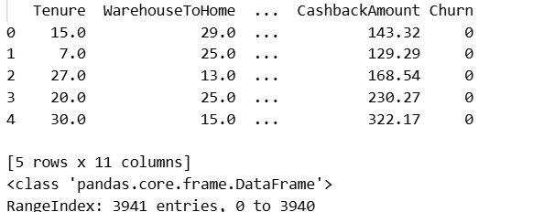

Fig. 2. Sample Data Record

APPENDIX C: SOURCE CODE IMPLEMENTATION
The project was implemented using Python programming language with machine learning and data analysis libraries.
Important Python libraries used:
- Pandas
- NumPy
- Scikit-learn
- Matplotlib
- Seaborn
- Joblib
Example Code Snippet:
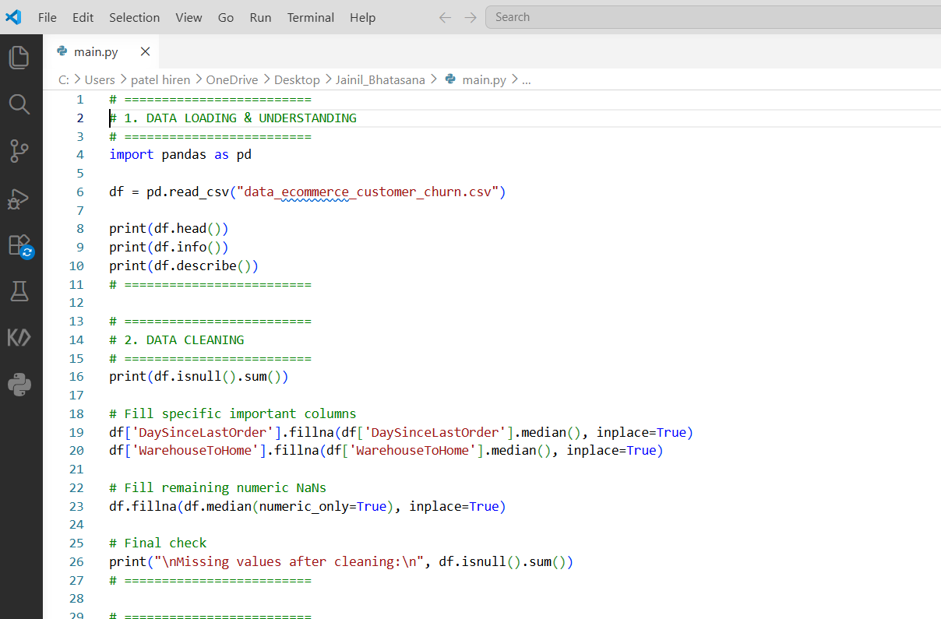
Fig. 3. Code Snippet

Additional code implementation includes:
- Data preprocessing
- Missing value handling
- Label encoding
- RFM feature engineering
- K-Means clustering
- Random Forest classification
- ROC curve generation
- Feature importance analysis

APPENDIX D: MACHINE LEARNING MODEL OUTPUTS
The following outputs were generated during model implementation and evaluation:
Component | Result
Churn Prediction Accuracy | 94%
ROC-AUC Score | 0.98
Number of Clusters | 4
Clustering Algorithm | K-Means
Classification Algorithm | Random Forest
Table 1. Model Output
The Random Forest classifier demonstrated strong predictive capability for customer churn analysis.

APPENDIX E: VISUALIZATION OUTPUTS
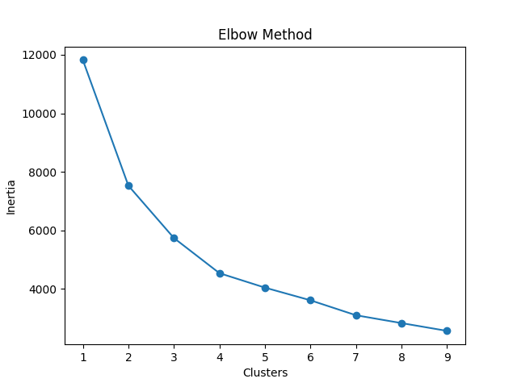
Figure 3: Elbow Method for Optimal Cluster Selection

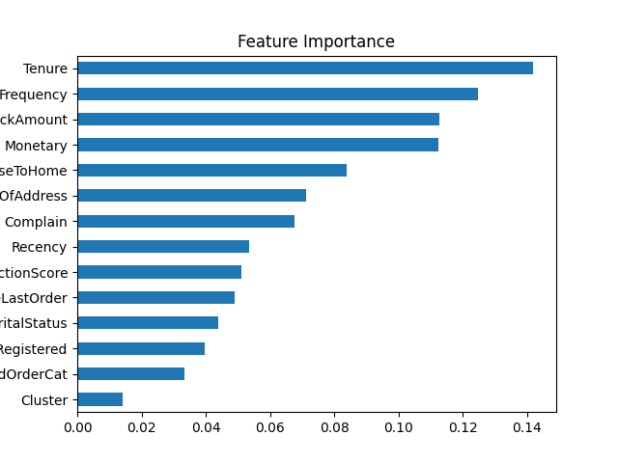
Figure 4: Feature Importance Analysis Using Random Forest
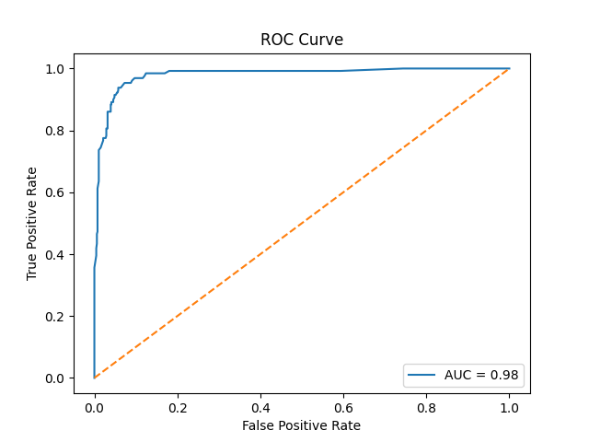
Figure 5: ROC Curve and AUC Analysis for Churn Prediction

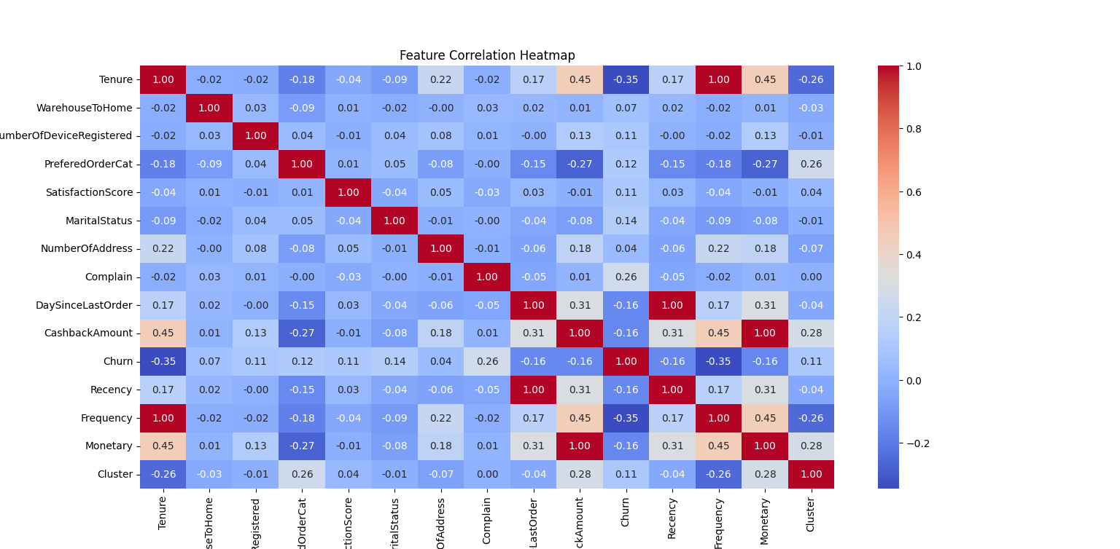
Figure 6: Feature Correlation Heatmap

APPENDIX F: GITHUB REPOSITORY LINK
GitHub Repository Link: https://github.com/jainil24-patel/E-Commerce-Customer-Churn-Analysis

